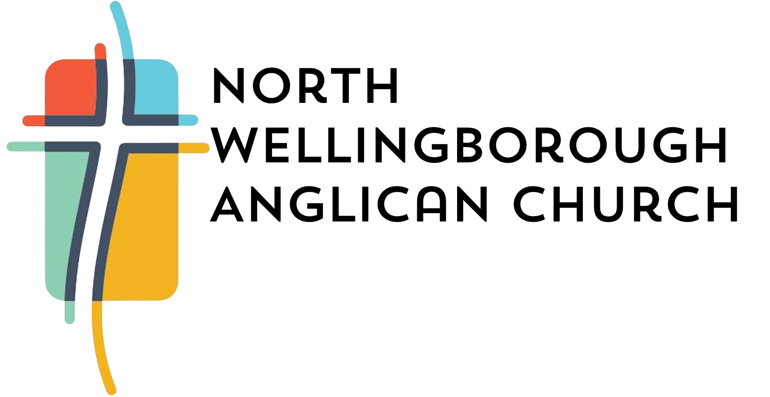

Community Children’s and Youth Worker for the parish of
North Wellingborough Anglican Church

Do you love being with children?
Do you feel passionately about growing faith amongst younger generations?
Do you enjoy being part of a team?

Whether you’re an experienced children’s and youth work practitioner or right at the start of your journey, we’re open to conversations with anyone that has a heart for helping our church to build a team as we pass the Gospel on to the next generation.

We’re looking to appoint a part-time children’s and youth worker, but you don’t have to be qualified or have experience of working for a church. We’re looking for the right person who we can invest in, not someone who is the finished article.

- Flexible part-time working
- ‘On the job’ training
- Opportunities to be creative and learn new skills

This is a newly created role for 3 years.

For Job Description and Application Form click the link below:
Children and Youth Worker Job – North Wellingborough Anglican Church

-Send your application form to Revd Dawn Airey vicar@nwanglicanchurch.co.uk
(If you would like an informal chat before applying please email Revd Dawn).

Closing date: 24th Dec 2025, interviews in January 2026

Ways to connect with us:
Website: https://nwanglicanchurch.co.uk/
Facebook: https://www.facebook.com/nwanglicanchurch
Youtube: https://www.youtube.com/channel/UCH2ajsMBC7RLkWjTmRvj38g

Instagram: https://www.instagram.com/gleneagleschurchwellingborough?igsh=MTk2aWN1aWpoOXBtZQ==

